UID: 504958165

Name: Kanisha Shah

1. Decision Tree

1.1

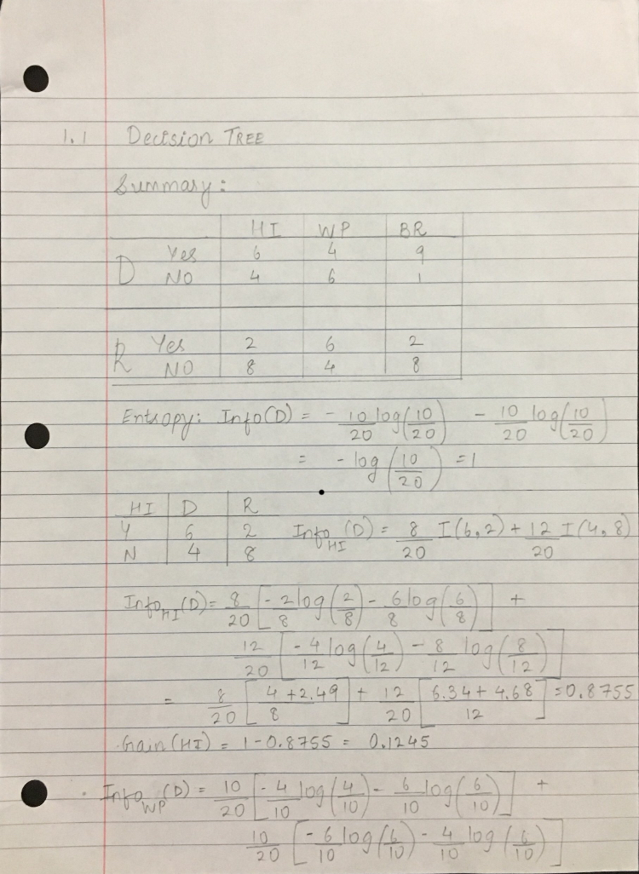

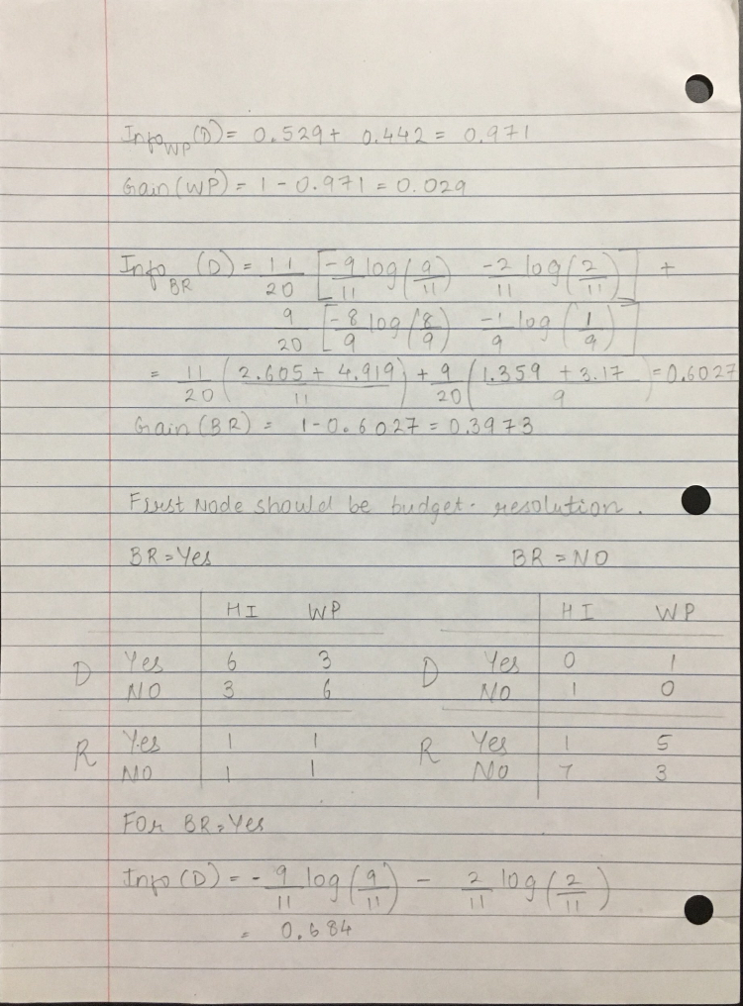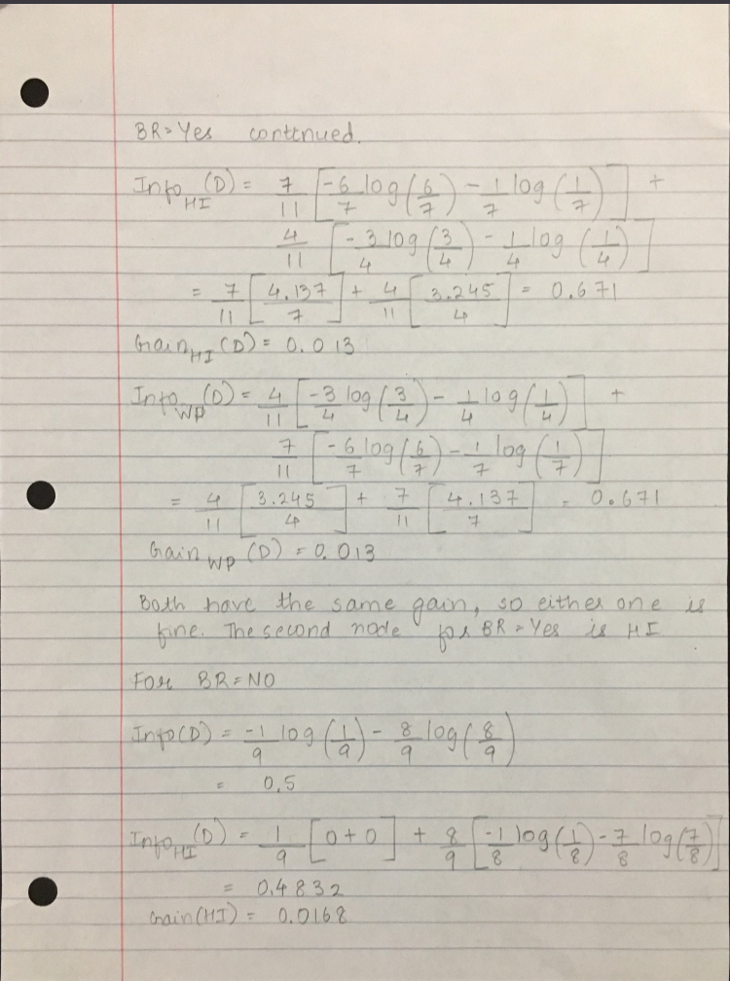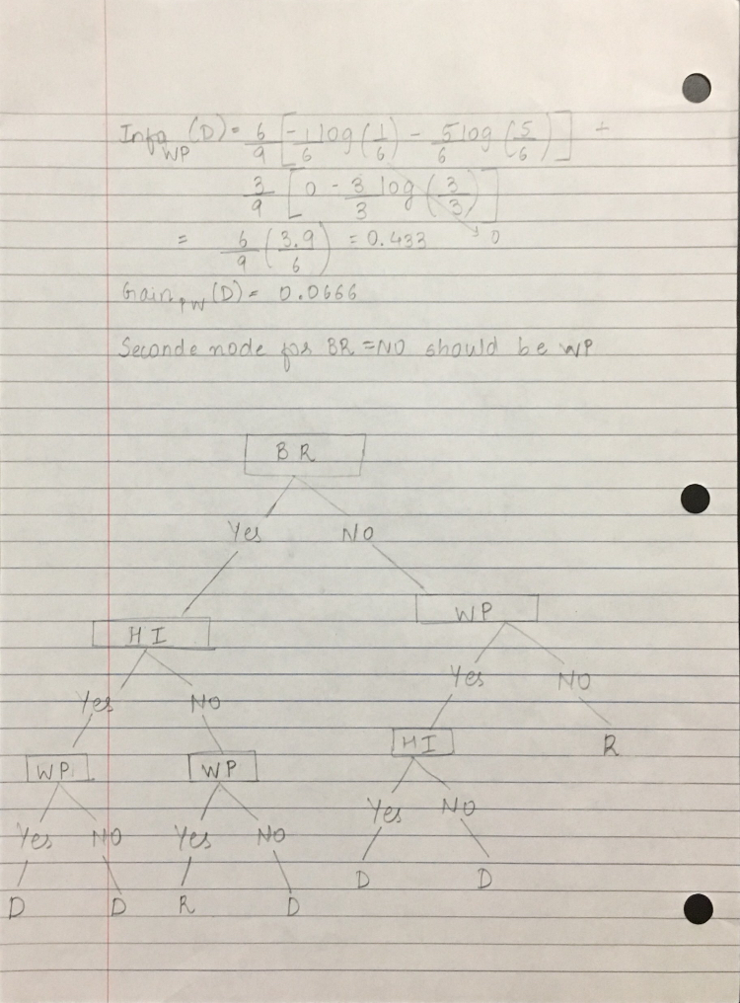

1.2

**Output of Information Gain:**

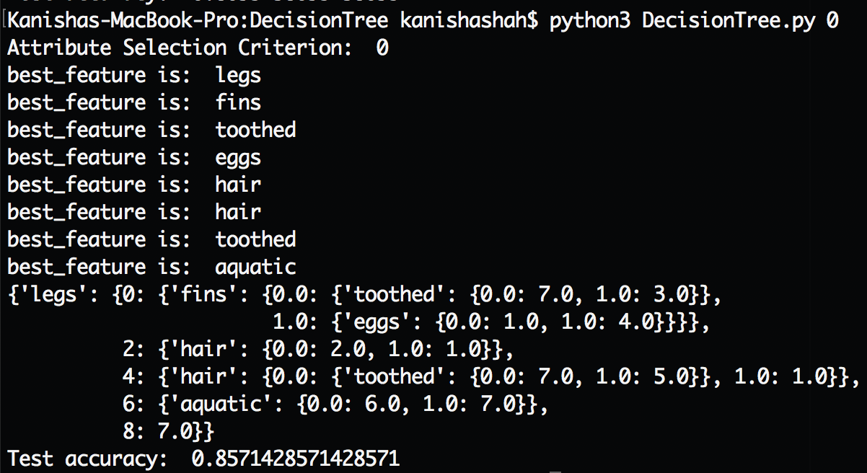

**Output of Gain Ratio:**

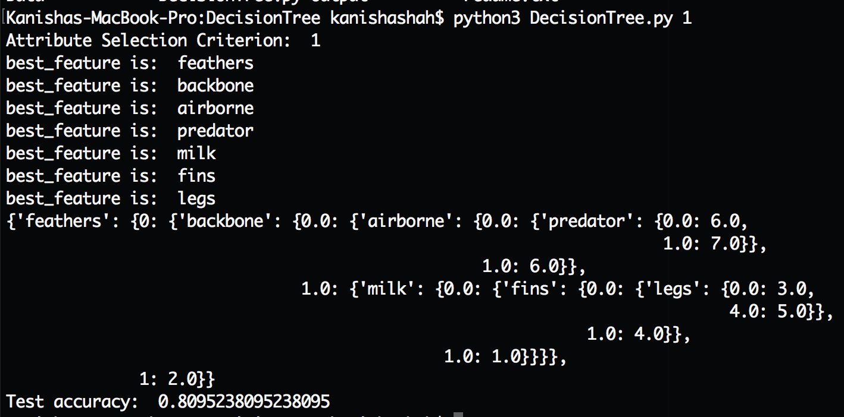

Information gain has an accuracy of 85.7% whereas the gain ratio has an accuracy of 80.92%. Information gain is biased towards choosing attributes with a large number of values as root nodes. This functionality of information gain makes it fit out model better. Both of them have bias, but since, Information gain has a high accuracy, we would use that for attribute selection.

2. SVM

2.1

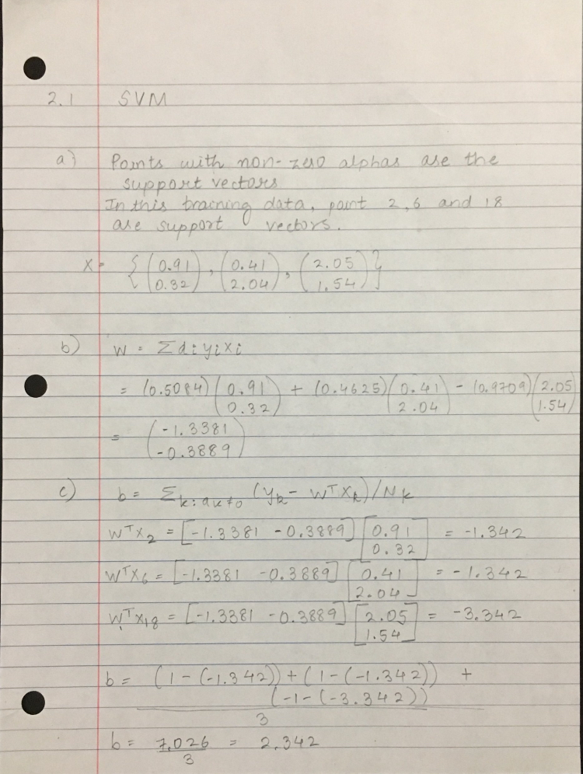



(f)

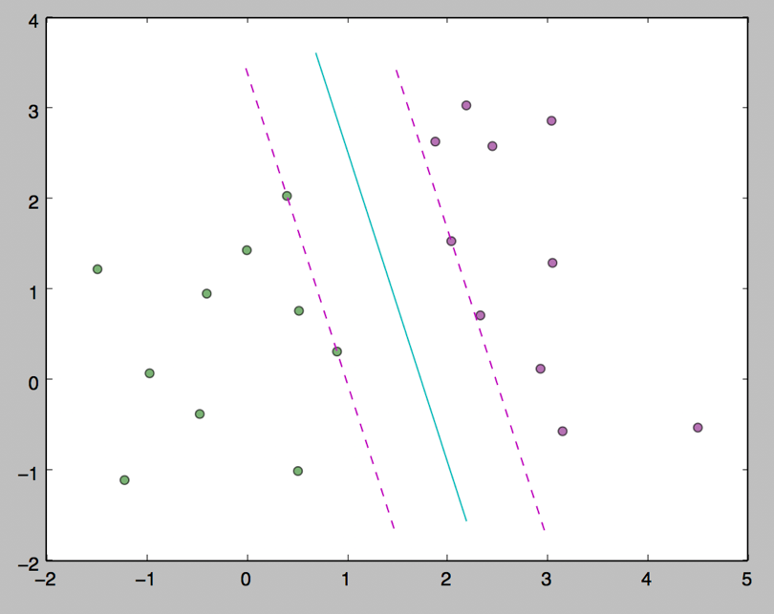

2.2

(a)

**Output of hard margin on linear kernel**

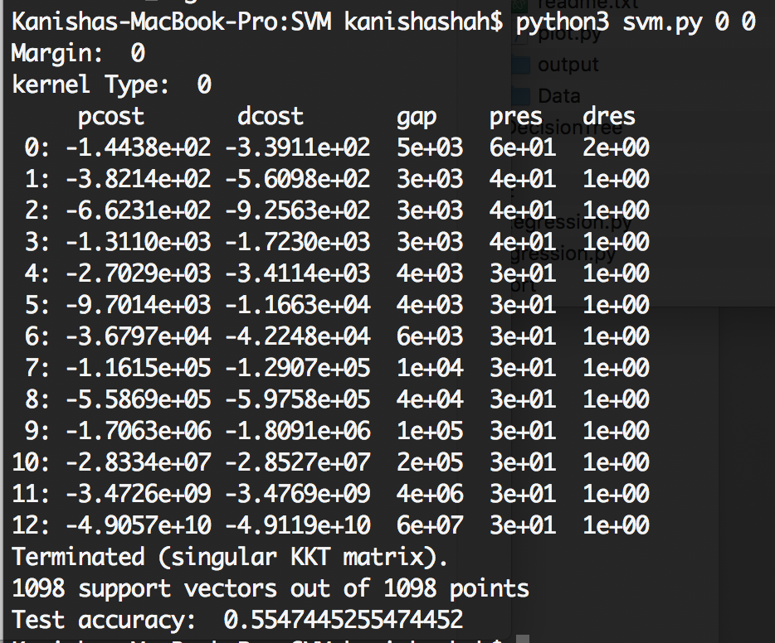

**Output of soft margin on linear kernel**

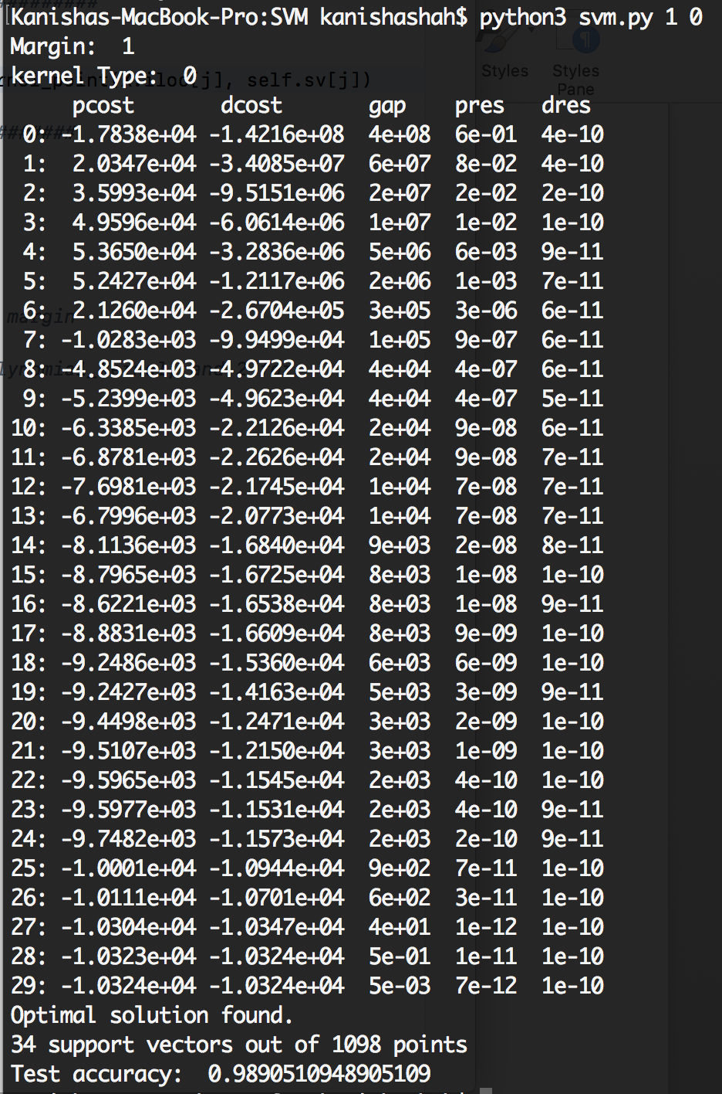

Soft margin for linear kernel gives us an accuracy of 98.9%. Hard margin for linear kernel gives us an accuracy of 55.47%. In a hard-margin SVM, a single outlier can determine the boundary, which makes the classifier overly sensitive to noise in the data. Soft-margin SVM is an extended version of hard-margin SVM with some slack variables. Hard-margin needs data to be completely linearly separable whereas this is not the case with soft-margin. Since, the accuracy for soft margin is also greater, we would choose that model.

(b)

**Output of soft margin on linear kernel**



**Output of soft margin on polynomial kernel**

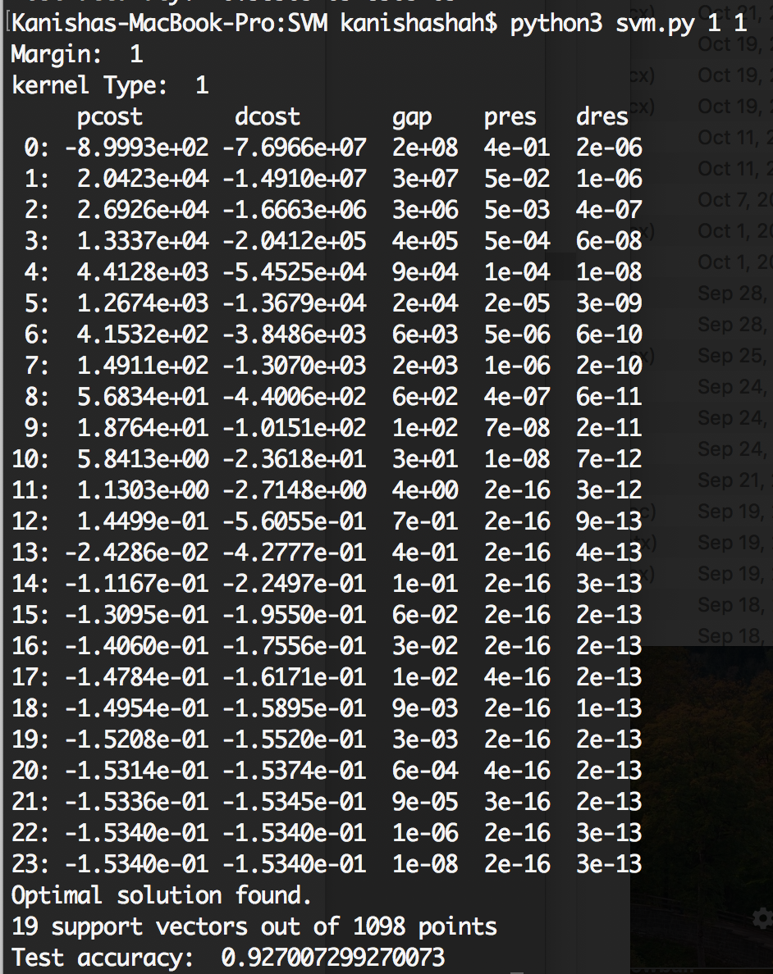

**Output of soft margin on gaussian kernel**

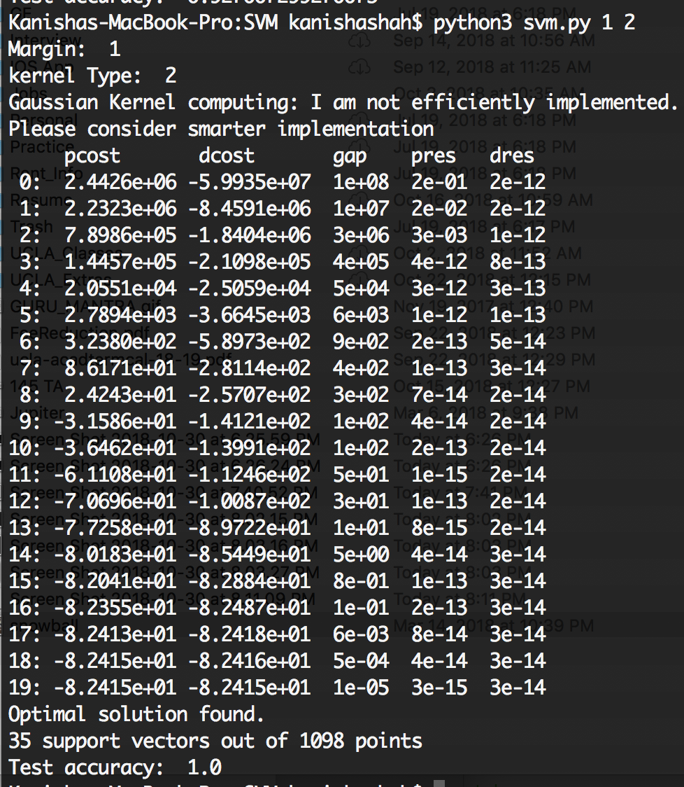

Accuracy for soft margin on linear kernel is 98.9%. Accuracy for soft margin on polynomial kernel is 92.7%. Accuracy for soft margin on Gaussian kernel is 100%. Gaussian kernel gives you access to all analytic functions (that is all infinitely differentiable functions). So, we can obtain more accurate hyperplanes. Since, the accuracy for gaussian kernel is also greater, we would choose that model.